Extentrix Web Interface for Microsoft SharePoint 2013

Administrator’s Guide
3.0

NOTICE
Extentrix Systems, makes no representations or warranties with respect to the contents or use of this publication. Extentrix specifically disclaims any express or implied warranties, merchantability, or fitness for any particular purpose. Extentrix reserves the right to make any changes in specifications and other information contained in this publication without prior notice and without obligation to notify any person or entity of such revisions or changes.
No part of this publication may be reproduced or transmitted in any form or by any means, electronic or mechanical, including photocopying, recording, or information and retrieval systems for any purpose other than the purchase’s personal use without express written permission of:
Extentrix Systems
P.O.Box 4404
Dubai, UAE
http://www.extentrix.com
Copyright and Trademark Notice
Information in this document is subject to change without notice. Companies, names, and data used in examples herein are fictitious unless otherwise noted. Other than printing one copy for personal use, no part of this document may be reproduced or transmitted in any form or by any means, electronic or mechanical, for any purpose, without the express written permission of Extentrix Systems.
Copyright © 2013-2019 Extentrix Systems, Inc. All rights reserved.
Trademark Acknowledgements
Citrix, ICA (Independent Computing Architecture), and XenApp are registered trademarks of Citrix in the United States and/or other countries.
Microsoft, Windows, Office, Internet Information Services, SharePoint, SQL Server, ActiveX, and Active Directory are either registered trademarks or trademarks of Microsoft Corp. in the United States and/or other countries.

All other trademarks and registered trademarks are the property of their owners.

Table of Contents
Table of Contents 3
Table of figures 6
Introduction 8
How to Use this Guide 8
Introducing Extentrix Web Interface for Microsoft SharePoint 2013 9
Extentrix Web Interface for Microsoft SharePoint Features 9
Citrix Application Delivery 9
Content Redirection 9
Citrix HTTP Request Redirection 10
Citrix Context Menu Integration 10
Citrix New Menu Integration 10
Client Detection and Deployment Process 10
Other Features 10
File Locations 10
Planning the Deployment 12
SharePoint Deployments 12
Installing Extentrix Web Interface for Microsoft SharePoint 2013 12
Pre-Requisites 13
License Requirements 13
SQL Server Requirements 13
Other Requirements 13
Firewall Requirements 13
Installing Extentrix Web Interface for Microsoft SharePoint 13
Session State 14
installation 14
Post-Installation Tasks 16
Multiple farms 18
Managing Content Redirection 19
Managing Clients 23
Customizing the Appearance of the Web Part 24
Modifying the appearance of the Web Part 24
Use SharePoint master style sheet settings 27
Enable Event logging 29
Configuring Extentirx Web Interface for Microsoft SharePoint 31
Administration options 31
Managing Farms 31
access the Farms administration page 31
Uninstalling Extentrix Web Interface for Microsoft SharePoint 31
Before Uninstalling the Web Interface for Microsoft SharePoint 31
Uninstalling the Software 32
Creating Secure Store 33
Sharepoint Form Based authentication 37
SSO Based authentication – Citrix side setup 38
Checklist for server side and client side settings to enable SSO 38
Support 41
Troubleshooting Extentrix Web Interface for SharePoint 41
Using Log Files 41
.ICA Files location 41
change EWISP Layout 41
how to create event log If not created 41
MakeEnv.ps1 is not digitally signed. The script will not run on System. 41
I get permission error. 42
When I click on application icon, I get a HTTP 404 error. 43
Uninstall script fails to uninstall the ewips. 43
I get Type is not registered as safe. 43
Glossary 44
Index 45
About Extentrix 46

Table of figures
Figure 1: EWISP - Published Applications 9
Figure 2: EWISP - SharePoint Variables 15
Figure 3: EWISP - Edit Web Part Page 16
Figure 4: EWISP - Add a Web Part 16
Figure 5: EWISP - Adding the EWISP Web part 17
Figure 6: EWISP - Web Part Farms Settings 18
Figure 7: EWISP - Web Part Farms Settings view 18
Figure 8: EWISP – Adding new farm 19
Figure 9: EWISP - Web Part Installed 19
Figure 10: EWISP - Site Actions Menu 20
Figure 11: EWISP – Site Settings Page 21
Figure 12: EWISP – Content Redirection Page 21
Figure 13: EWISP – New File Type Association Dialog 22
Figure 14: EWISP – ICA Client Settings 23
Figure 15: EWISP - Web Part Appearance Settings 26
Figure 16: EWISP - Web Part Layout Settings 26
Figure 17: EWISP –Web Part Style Options 27
Figure 18 : EWISP - Web Part Miscellaneous Options 28
Figure 19 : EWISP – Secure Store Options 32
Figure 20 : EWISP – User Credntials Box 32
Figure 21 : EWISP – Target Application Settings 33
Figure 22 : EWISP – Add fields 34
Figure 23 : EWISP – Group Policy Management Editor 36
Figure 24 : EWISP – Allow Delegating Default Credentials 37
Figure 25 : EWISP – Citrix App Center 38
Figure 26 : EWISP – Permission error message 40
Figure 27 : EWISP – Type is not registered as safe error 41

Introduction
The Extentrix Web Interface for Microsoft SharePoint 2013 (EWISP) application allows an administrator to deliver XenApp published applications, desktops and/or content in the SharePoint 2013 environment. The Extentrix WISP Web Part can be embedded into the relevant pages within the SharePoint site, allowing users to access their published applications, desktops and content.

How to Use this Guide
The Extentrix Web Interface for Microsoft SharePoint 2013 Administrator’s Guide is for Citrix administrators, Microsoft SharePoint administrators and Web masters responsible for installing, configuring, and maintaining Citrix XenApp Servers and the Web Interface for Microsoft SharePoint. This is a task-based guide to aid in setting up the Extentrix WISP quickly and easily.
This chapter introduces the documentation and the Extentrix Web Interface for Microsoft SharePoint 2013 features. Subsequent chapters explain how to deploy and configure it.
This guide assumes knowledge of Citrix XenApp, Microsoft SharePoint, and Internet Information Services (IIS) Manager

Introducing Extentrix Web Interface for Microsoft SharePoint 2013
The Extentrix Web Interface for Microsoft SharePoint 2013 provides SharePoint users with access to Citrix XenApp resources using a Web browser.
Further information regarding Microsoft SharePoint browser support and browser compatibility, with particular SharePoint features from the Microsoft Web site, www.microsoft.com – and search for “Plan browser support (SharePoint Server 2013)”

Extentrix Web Interface for Microsoft SharePoint Features
The Extentrix Web Interface for Microsoft SharePoint 2013 includes the following functionalities:

Citrix Application Delivery
The EWISP Web Part displays the resources to which users have been given access within a Citrix server farm; it also allows the user to launch those resources.
Packaging this as a Web Part allows a SharePoint Web Designer to include the ability to access those resources from any page in the SharePoint site.
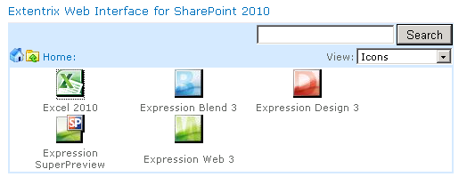
Figure 1: EWISP - Published Applications

Content Redirection
Content redirection allows users to access content stored in the SharePoint site using published applications. This is important if users cannot install applications locally.
Content redirection includes three features: Extentrix HTTP Request Redirection, Extentrix Context Menu Integration, and Extentrix New Menu Integration. These features provide greater control over how users access their resources. Content redirection works over the whole SharePoint site, and integrates with HTML links.
Content redirection requires the remote application to be able to open a document from a URL, and to accept a URL as its first parameter.

Citrix HTTP Request Redirection
This feature allows users to open SharePoint resources automatically using applications delivered by Citrix. You can specify which file types open which published applications. If a published application cannot be launched, you can configure local fallback to open the document locally instead.
_____________________________________________________________________________
Note Dependent upon the Internet Explorer security settings in the environment, users may be prompted for credentials when editing SharePoint content using applications delivered by Citrix.
________________________________________________________________________

Citrix Context Menu Integration
The Document Center and Shared Documents provide context menus that let users edit files using applications installed locally. The Web Interface for Microsoft SharePoint 2007 modifies the existing document context menu, allowing users to open and edit documents using applications delivered by Citrix. This gives users explicit control over how they access their documents. You can configure which types of files open which published applications.

Citrix New Menu Integration
Users can choose the Document Delivered by Citrix option from the New menu in the Document Center or Shared Documents to create a new document using an application delivered by Citrix. You can configure which document types can be created using which published applications.

Client Detection and Deployment Process
The client detection and deployment process detects which clients can be deployed within a user’s environment and then provides the user a proper link to download the ICA client. This ensures that users get an optimal launch experience when accessing their applications and content.

Other Features
The Web Interface for Microsoft SharePoint also includes the following functionality, currently available through Citrix Web Interface and Citrix XenApp:
- Display of published resources available for the user organized into Program Neighborhood folders
- Access to published resources using seamless connections
- Integrated Windows authentication
- Farm aggregation, assuming a single set of credentials for all farms

File Locations
Throughout this document, the following file locations are used:
- webroot,: usually C:\inetpub\wwwroot\wss\VirtualDirectories\80\
- sharepoint,: common files\Microsoft Shared\web server\extensions\14\

Planning the Deployment
This chapter contains information on planning the SharePoint deployment and other considerations and requirements specific to the Extentrix Web Interface for Microsoft SharePoint 2013.

SharePoint Deployments
SharePoint 2013 supports many different deployment scenarios, or topologies, including deployments on a single server or in a server farm.
Different physical servers within a SharePoint server farm have different server roles. A SharePoint server farm includes one or more database servers and one or more servers filling the Web server and Application server roles. The Web and Application servers can be configured for load balancing.
These roles are as follows:
Web Server: Web servers are front-end servers that provide access to the Share Point environment from an Internet browser. A single physical server can function as both a Web server and an Application server.
Application Server: Application servers are front-end servers that provide SharePoint functionality such as searching and indexing. A single physical server can function as both an Application server and a Web server.
Database Server: Database servers are back-end servers running Microsoft SQL Server 2008 with SP1.

Installing Extentrix Web Interface for Microsoft SharePoint 2013
This chapter explains how to install and configure Extentrix Web Interface for Microsoft SharePoint 2013.
Topics in this chapter include:
- System Requirements
- Other Requirements
- Installing the Web Interface for Microsoft SharePoint
- Post-Installation Tasks
- Troubleshooting the Web Interface for Microsoft SharePoint Installation
- Uninstalling the Web Interface for Microsoft SharePoint

Pre-Requisites
Before installing the Web Interface for Microsoft SharePoint, Microsoft SharePoint 2013 must be installed and configured.
It is important to ensure that the server on which Extentrix Web Interface for Microsoft SharePoint 2013 will be installed is configured with the Application server role.

License Requirements
To get a valid or trial license DLL, please email sales@extentrix.com the MAC address of the SharePoint server you are installing the EWISP on. Extentrix will send you Ext-License.dll. This file needs to be copied to web root binary directory. I.e. something similar to this path C:\inetpub\wwwroot\wss\VirtualDirectories\80\bin

SQL Server Requirements
If the SharePoint environment uses Microsoft SQL Server 2008 for the SharePoint database, the local administrator account used to run the EWISP installation has system administrator rights to the SharePoint configuration database running on SQL Server.

Other Requirements

Firewall Requirements
If a firewall is used in the environment, TCP port 1494 must be open to be able to launch published applications on Citrix XenApp.

Installing Extentrix Web Interface for Microsoft SharePoint
This section explains how to install the Extentrix Web Interface for Microsoft SharePoint 2013. This involves adding solutions to the solution store, deploying the solution files from the configuration database to a Web server, and activating the features on the SharePoint site. The Extentrix Web Interface for Microsoft SharePoint consists of the following files:
- PowerShell script files:
DeploySolution.ps1 – used to deploy the WISP SharePoint package to the SharePoint server
UnistallSolution.ps1- used to uninstall the WSP SharePoint package from the SharePoint server
ReDeploySolution.ps1 – used to redeploy the WSP SharePoint package
MakeEnv.ps1 – used to modify the environment configuration
EnableSessionState.ps1 – used to enable the state service
FolderPermissions.ps1 – used to give users permission to where icons files stored
UninstallSolution.ps1 – used to uninstall the web part
Note: “Set-ExecutionPolicy Unrestricted” maybe required to be called as the script files are not signed
- WISP SharePoint package file ExtentrixWebIntrface.wsp that contains the WISP web part and additional lists.
- Configurations file for logging ExtentrixWebIntrface.log4net.config.

The install process uses the SharePoint Power Shell administration tool. For more information about this tool and its parameters, see the Microsoft Developer Network Web site, http://msdn.microsoft.com/.

Session State
EWISP would use session state. Please ensure the following is in your SharePoint site web.config file:
<httpModules>
< add name="Session" type="System.Web.SessionState.SessionStateModule"/>
< /httpModules>

installation
______________________________________________________________________________________
Notes
To complete the installation the logged in account must have SharePoint server farm administrator permissions, i.e. a member of the administrators group on each of the Web and Application servers, as well as SQL security administrator with database creator rights on each of the relevant SQL servers.
The installation has to be done on SharePoint Web Server
- Edit MakeEnv.ps1 file with text editor (such as Notepad) and change the following variables (below is an example from our environment and the settings will be different in your setup. Please refer to the images below to find out how picked up the values):
- $global:WebApplication = "SharePoint - 80": This is the web application name. Default web application name is "SharePoint - 80"
- $global:SiteUrl = "http://WIN2K8SP": This is the URL for site collection.

The following image shows how to include these values in the SharePoint environment.
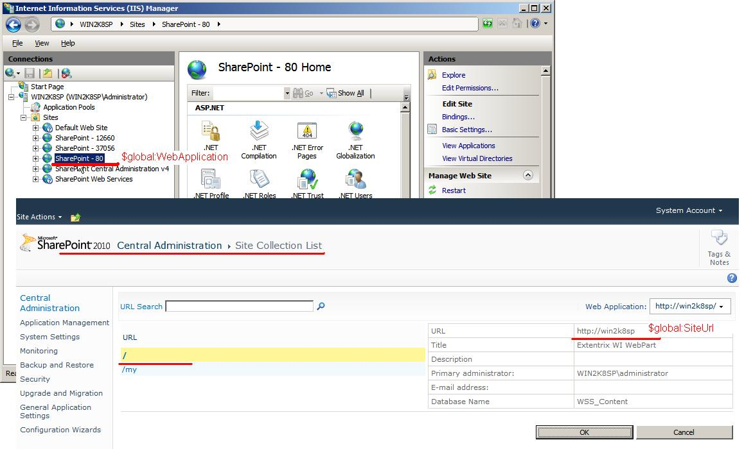
Figure 2: EWISP - SharePoint Variables
- Run SharePoint Power Shell environment (Please don’t use Windows PowerShell).
- Change the directory to the location of the installation script files.
- Type “.\MakeEnv.ps1”, press Enter.
- Type “.\DeploySolution.ps1”, press Enter.
- Type “.\EnableSessionState.ps1”, press Enter.
- Type “.\FolderPermissions.ps1”, press Enter.
- Copy Ext-license.dll (Please Check Pre-Requisites section) to web root binary directory. Something like this path: C:\inetpub\wwwroot\wss\VirtualDirectories\80\bin

Note In a SharePoint server farm, the EWISP solution requires installation to one of the farm’s Web servers only. If it is installed on the administration server, then FolderPermissions.ps1 has to run also on all Web servers.

Post-Installation Tasks
After installing the Web Interface for Microsoft SharePoint 2013, you need to allow users to access XenApp from a SharePoint site. To do so, add Extentrix Web Interface for SharePoint to a Web Part Page.
- Logon to the SharePoint site as either an administrator or Web Designer.
- Select the page to add the web part into.
- On the Site Actions menu, choose Edit Page.
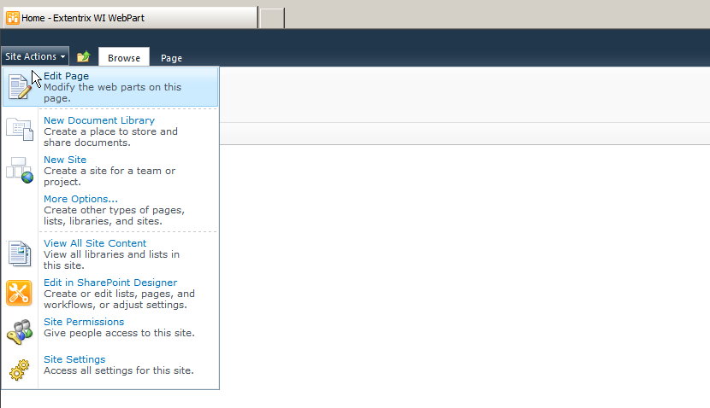
Figure 3: EWISP - Edit Web Part Page
- Click on Insert
- Click on Web Part
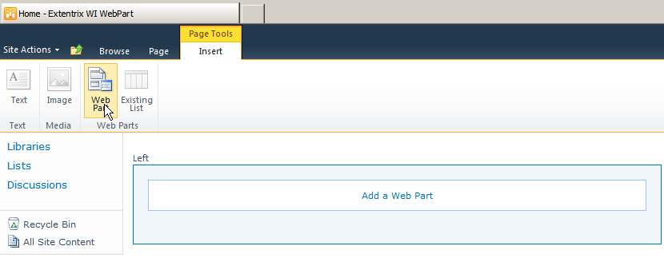
Figure 4: EWISP - Add a Web Part
- Click on “Custom” and select Extentrix Web Interface for SharePoint
- Click Add.
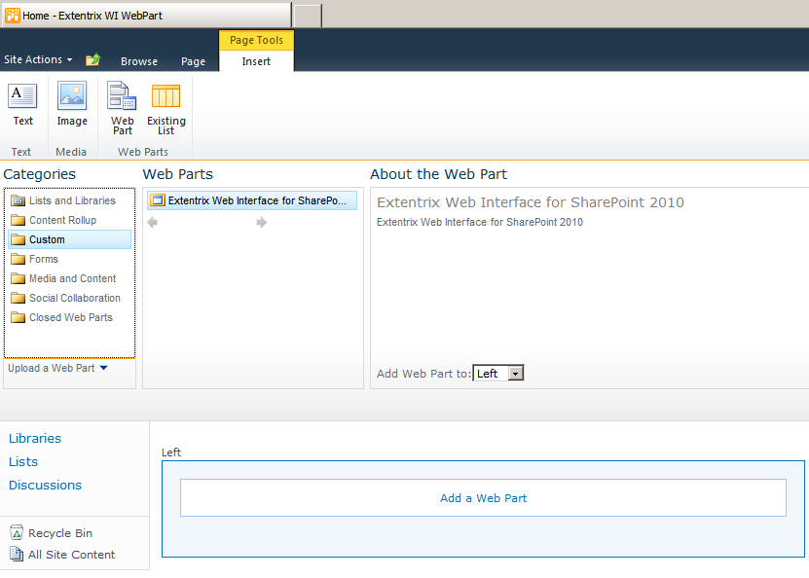
Figure 5: EWISP - Adding the EWISP Web part
- The EWISP web part will show on the page with empty applications.
- You need to add the Citrix XenApp IP address or FQDN. Please click on Site Actions > Site Settings > Extentrix WISP Settings.

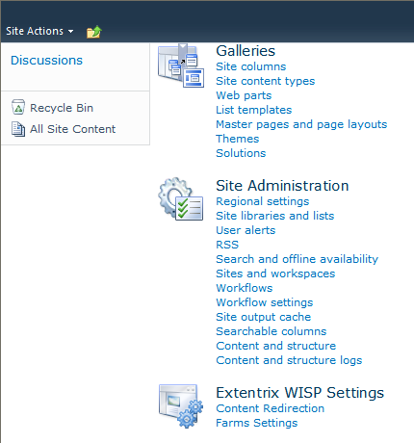
Figure 6: EWISP - Web Part Farms Settings
- Choose Citrix Farms Configuration

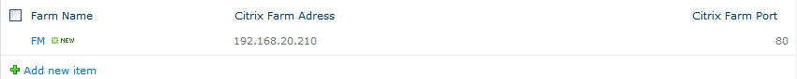
Figure 7: EWISP - Web Part Farms Settings view
- Click on “Add new item”. A popup window will show up and please enter friendly name for the farm name. Please enter FQDN or IP address of your XenApp server. And the XML port. Then click save.

Multiple farms
EWISP supports many farms you may have in your organization. You need to add them one after the other by repeating steps 11 for each farm.

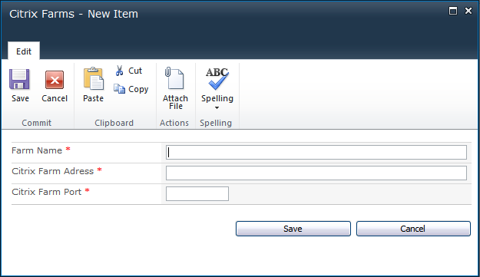
Figure 8: EWISP – Adding new farm
- After you are done, the published applications will be rendered in the web part.
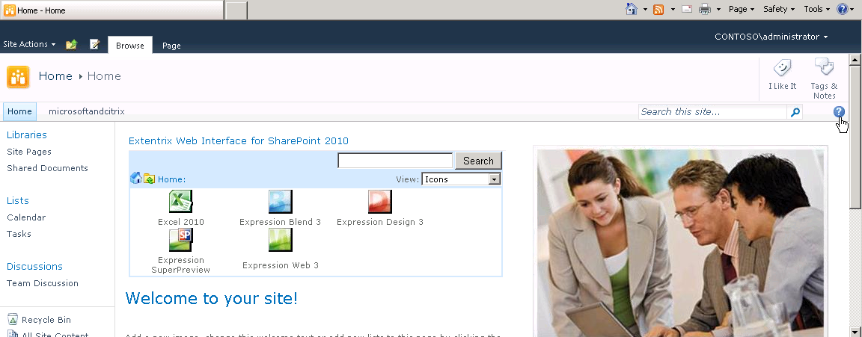
Figure 9: EWISP - Web Part Installed

Managing Content Redirection
Content redirection allows you to open content published in SharePoint using applications published by Citrix XenApp. You may want to make use of this functionality if users cannot access applications locally or if bandwidth is an issue. The Content Redirection Administration page allows you to manage, add, and remove the file extensions that support content redirection.

Note Content redirection relies on file name extensions being associated with published applications. Therefore, you must ensure that published applications support any of the filename extensions that you plan to create. For more information, see the Citrix XenApp Administrator’s Guide.

To access the content redirection administration pages
- Ensure you are logged on to the SharePoint site as an administrator.
- From the Site Actions menu, choose Site Actions.
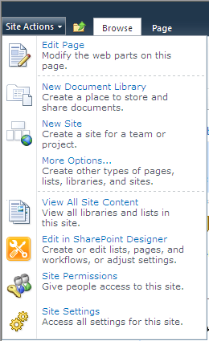
Figure 10: EWISP - Site Actions Menu
- Choose Site Settings.
- Choose Content Redirection under Extentrix WISP Settings.
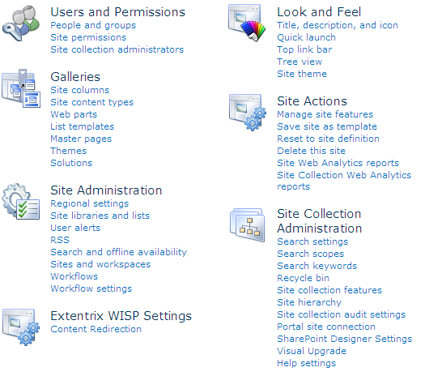
Figure 11: EWISP – Site Settings Page
- In this page, you could add new extensions or delete extensions. Also you could enforce the user to use the published applications even though user may have applications installed locally that could open published documents.
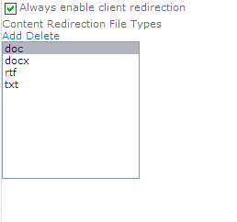
Figure 12: EWISP – Content Redirection Page
- Click on Add and it will pop you this dialog to add file extensions associated with apps.
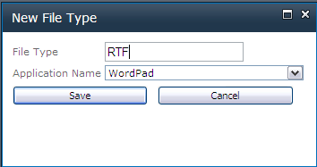
Figure 13: EWISP – New File Type Association Dialog

Managing Clients
The client detection and deployment process helps the user to get the most appropriate client for their situation.
The Clients administration settings allow you to specify a link to page where the user can download the required ICA client with instructions on how to do it. You need also to specify the ICA Client version to check against. If the user has a client version less than what specified, he will be prompted to download new ICA client.
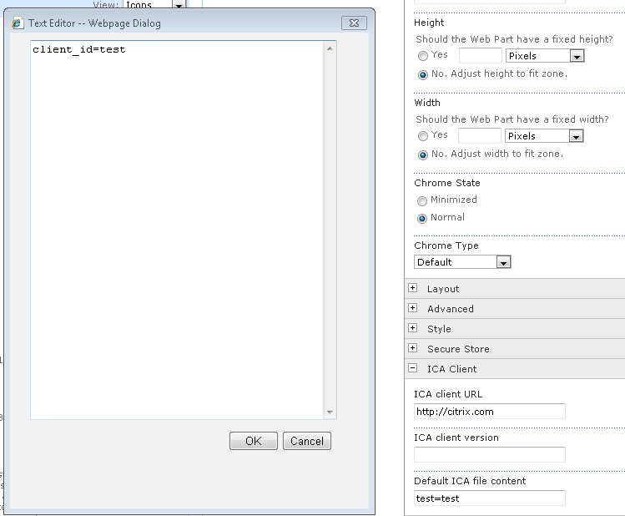
Figure 14: EWISP – ICA Client Settings

Customizing the Appearance of the Web Part
The appearance of the Extentrix Web Interface for SharePoint can be customized after installation.
The standard Web Part tool pane consists of the following areas:
- Appearance
- Layout
- Advanced options
These allow modification to the size of a Web Part, where it appears on the screen, and whether it can be minimized or closed by a user. For more information, see the Microsoft SharePoint 2013 documentation.
Extentrix Web Interface for Microsoft SharePoint also includes Preferences and Style options. These make it possible to hide Citrix Presentation Server resources, and customize how those resources appear in the Web Part.

Modifying the appearance of the Web Part
- Select the page to edit.
- From the Site Actions menu, choose Edit Page.
- Click the arrow for the Web Part to be modified.
- Click Edit Web Part.
- Choose from the following:

To... | Do this...
Change height of Web Part | Expand Appearance and select Height
Change width of Web Part | Expand Appearance and select Width.
Set logging preferences | Expand Preferences and select appropriate option.
Specify body border width | Expand Style and enter the width size in number of pixels Body border width box.  The default value is 2.
Specify body border color | Expand Style and enter the color for the border Body border color box. The default value is #D6E8FF.
Specify body background color | Expand Style and enter the color for the border Body background color box. The default value is #FFFFFF.
Specify Toolbar background color | Expand Style and enter the color for the border Toolbar background color box. The default value is #D6E8FF.
Append Prefix in front of client Name | Expand Miscellaneous and enter the prefix in the Client Name Prefix.
Get Product information | Expand Miscellaneous and you will find the product name, version and copyright.
Change event logging storage | Expand Miscellaneous and you can change it log file or event viewer. Log file is location is specified in ExtentrixWebIntrface.log4net.config
Filter Applications user could see in the web part | Expand Miscellaneous and check “Apply application filter” then enter applications names you want the user to see separated with “,” and no white spaces.
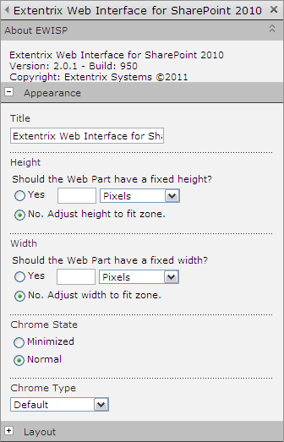
Figure 15: EWISP - Web Part Appearance Settings
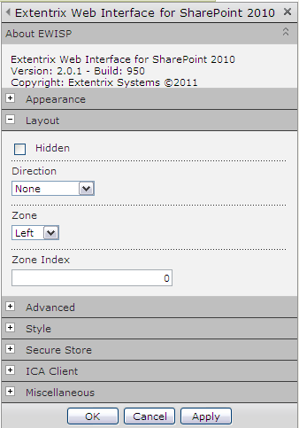
Figure 16: EWISP - Web Part Layout Settings

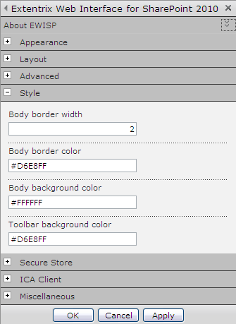
Figure 17: EWISP –Web Part Style Options

Use SharePoint master style sheet settings
If you would like to use SharePoint Master Style sheet settings, you need to remove all the values from the style options listed in Figure 17.
Also note that the icons will be listed according to the size of the web part.
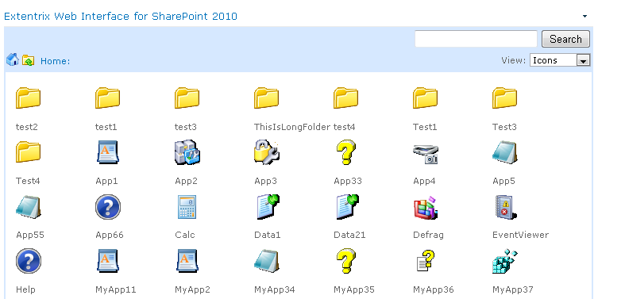
Figure 18: EWISP –Web Part Style Options
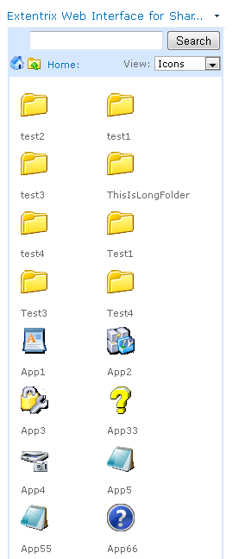
Figure 19: EWISP –Web Part Style Options
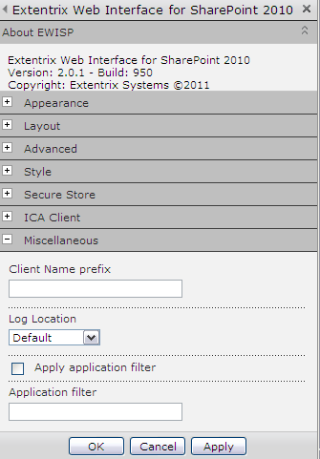
Figure 20 : EWISP - Web Part Miscellaneous Options

Note Default log location option will write logging information into SharePoint system Log files located in c:\Program Files\Common Files\Microsoft Shared\web server extensions\14\LOGS.
You can control Detailed logging through the Extentrix.config (which is located in path similar to C:\Program Files\Common Files\Microsoft Shared\Web Server Extensions\14\CONFIG\Extentrix\Extentrix.config)
The value are listed below (which takes true or false):
<add key="LogInfo" value="false"/>
<add key="LogDetInfo" value="false"/>

Enable Event logging
Logging EWISP events to MS event facility would require specific privileges. To enable logging for SharePoint the following steps should be implemented:
- Go to IIS and find SITE on which SharePoint application installed (I.e.: DefaultWebSite)
- Go to Advanced Settings for Application and find Application Pool (DefaultWebSite)
- In Application pools choose appropriate pool (DefaultWebSite) and go to Advanced Settings
- Find Identity (I.e.: SP\Administrator);
- Run regedit.exe go to HKEY_LOCAL_MACHINE\SYSTEM\CurrentControlSet\services\eventlog\ permissions, add user SP\Administrator and allow Full Control
- Do step 5 for HKEY_LOCAL_MACHINE\SYSTEM\CurrentControlSet\services\eventlog\Security
- Restart IIS

Configuring Extentirx Web Interface for Microsoft SharePoint
This chapter describes how to administer and configure the Web Interface for Microsoft SharePoint.

Administration options
The Administration view enables control of Extentrix specific SharePoint settings. Access it by selecting the Administrator option in the pull down menu.

Managing Farms
The Farms administration page enables management of various aspects of the relationship of EWISP to Citrix server farms, including adding, removing, renaming farms and rearranging the contact order in which those farms are accessed.

access the Farms administration page
- Ensure you are logged on to the SharePoint site as an administrator.
- From the EWISP Web Part pull down menu, choose Administration.
- Click Citrix Farms Configuration.
The Farms page lists all the Citrix farms used by the SharePoint site, in contact priority order. To change the contact order, click the down arrow next to a farm and choosing to move it either up or down the list.
Using the Edit menu is possible to add a new farm or remove all the server farms. Any farm added must already be deployed and administered using the Delivery Suite Console.

Uninstalling Extentrix Web Interface for Microsoft SharePoint
This section explains how to uninstall Extentrix Web Interface for Microsoft SharePoint. You may have to perform some extra tasks after uninstalling the software to complete successfully.

Before Uninstalling the Web Interface for Microsoft SharePoint
Extentrix recommends you remove the Extentrix WISP Web Part from your all pages and the Web Part Gallery before uninstalling the software

- Ensure you are logged on to the SharePoint site as either an administrator or Web Designer.
- Select the page you want to edit.
- From the Site Actions menu, choose Edit Page.
From the menu of the Web Part you want to remove, choose Delete.
- At the dialog box prompting you to confirm the permanent removal of the Web Part, click OK.

Uninstalling the Software
To uninstall Extentrix Web Interface for Microsoft SharePoint you need to follow the steps below:
- First, run SharePoint PowerShell.
- Change directory to EWISP script files using “CD” command.
- Type “.\ UnistallSolution.ps1” then press Enter.

Creating Secure Store
Extentrix has added another way for logging to Citrix XenApp. If you click on “Use Secure Store”, you will be prompted to enter credentials to login to EWISP as show in Figure 20. If you would like the user to be logged in all the time, please type -1 in “Credentials Live Time”. If you like to limit user access to published applications, enter a numeric value that represents time in minutes. When it times out, the user will be logged out.
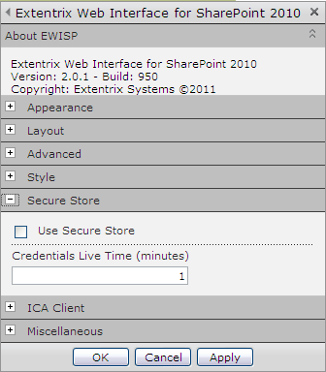
Figure 21 : EWISP – Secure Store Options

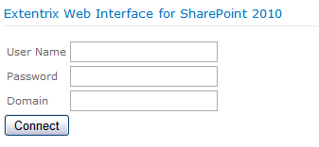
Figure 22 : EWISP – User Credntials Box

Please follow the instructions below to create a secure store used to store Citrix user’s credentials:
- Open Application Management in Central Administration and then Manage Service Applications. Click Secure Store Service Application. If you first time configure Secure Store Service Application, you will be prompted to generate a key because credential database is encrypted by using a key. In the future you will be able to re-encrypt the database using a new key. Click “Generate New Key” button on the ribbon. On the Generate New Key dialog, enter a pass phrase string in the Pass Phrase edit box, and type the same string in the Confirm Pass Phrase edit box. Click “OK”
- Now we are ready to create new Secure Store Target Application. Click “New” to create new Secure Store Target Application. Type Target Application ID “CitrixID” (must be exactly identical), fill in others fields and choose “Individual” as your Target Application Type and click “Next”.
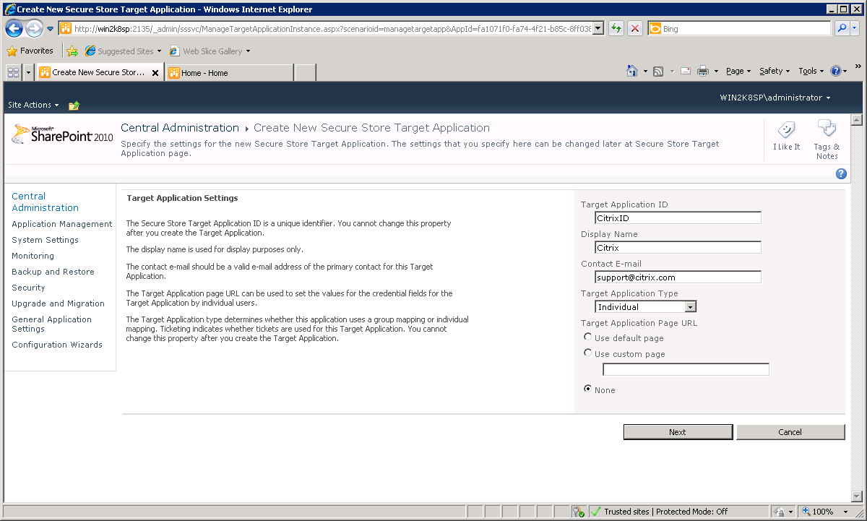
Figure 23 : EWISP – Target Application Settings
- In order to specify the credential fields for your Secure Store Target Application choose “Windows User Name” and “Windows Password” field types than “Generic” field type and fill “Domain” in the name for this field, click “Next”.
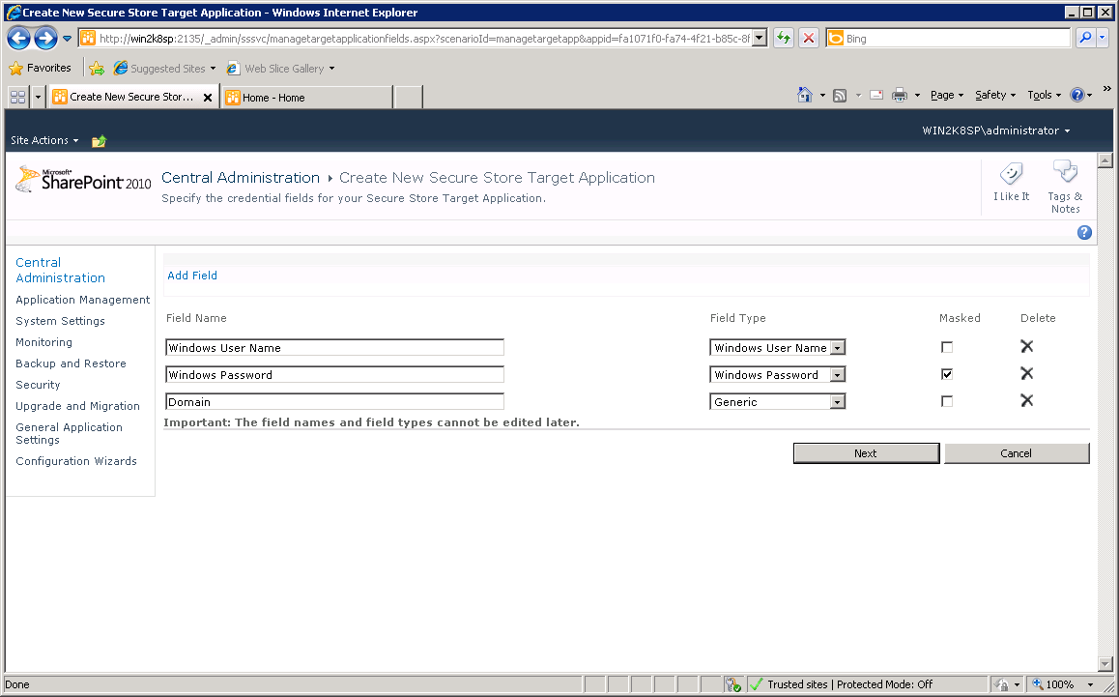
Figure 24 : EWISP – Add fields
- Add Target Application administrator and click “OK” button. Secure Store Target has been created.
- Make sure to add the account listed under application pool where the web app is running to the Secure Store Administrators as shown in the figures below.
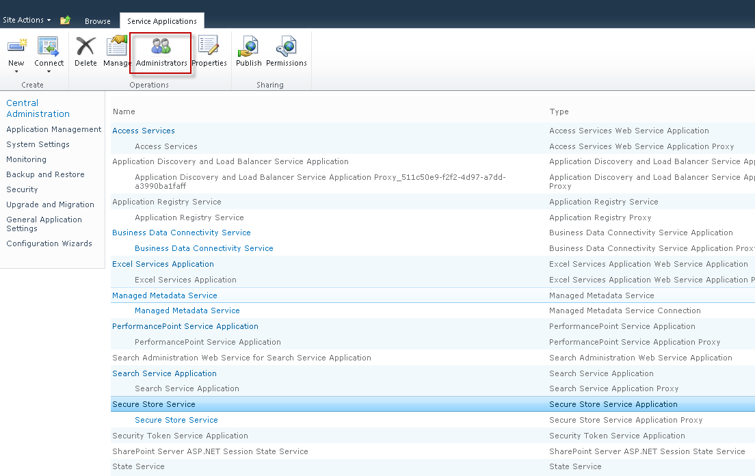
- Figure 25 : EWISP – Add fields
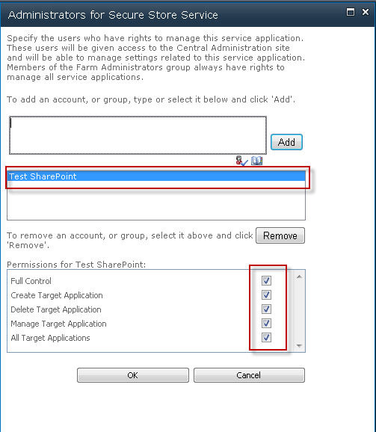
Figure 26 : EWISP – Add fields

Sharepoint Form Based authentication
Extentrix WISP support Microsoft SharePoint Form Based authentication. To enable that in EWISP, please the instructions below:
- Enable Secure Store (Extentrix Form Authentication) as mentioned in the section above.
- Follow the guidelines in this Microsoft document to enable FBA: http://blogs.technet.com/b/mahesm/archive/2013/04/07/configure-forms-based-authentication-fba-with-sharepoint-2013.aspx
- Restart the browser.

SSO Based authentication – Citrix side setup
Extentrix WISP supports SSO based authentication. To use SSO with EWISP, you need to have your Citrix environment setup for that. We are proposing some solutions as a help but it may not solve your issue. You need to contact Citrix Support for help.

Checklist for server side and client side settings to enable SSO
- Make sure you have all of the latest hotfixes and rollup packs on your Citrix servers. Please check Citrix web site for latest updates.
- Enable this GPO Policy (and apply it to you servers:)
- Go to Policy -> computer configuration -> administrative templates -> system -> credentials delegation.
- Look for: Allow Delegating Default Credentials.
- Enable Concatenate OS defaults with input above and goto Show.
- Add the name of your WI/PNA server (ie. CWI-2) and click OK.
- GPUDATE /Force on the DC and on the web interface server or reboot the server.
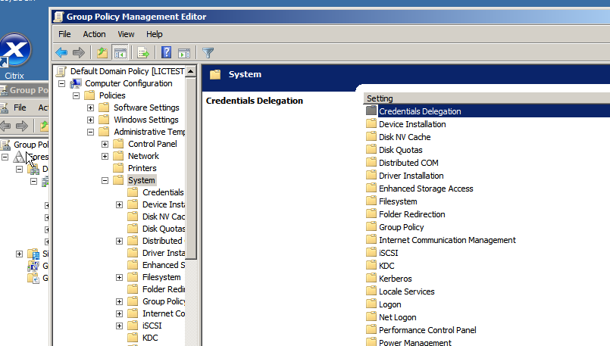
Figure 27 : EWISP – Group Policy Management Editor

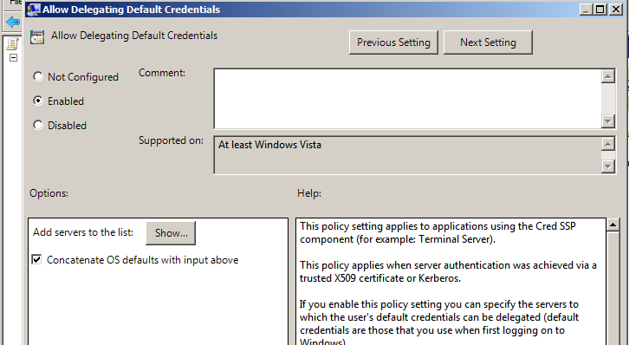
Figure 28 : EWISP – Allow Delegating Default Credentials

- At the same time, you can follow instructions in this article: http://support.citrix.com/article/CTX113004
- Make sure there are no Citrix policies in the AMC that require a password as below:

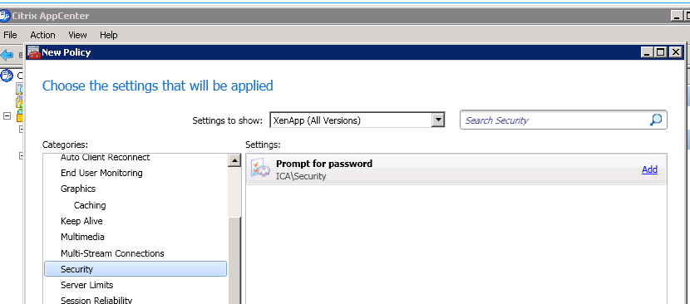
Figure 29 : EWISP – Citrix App Center

- On each Citrix server, launch the Terminal Services Configuration tool. Look to see if "Always Prompt for Password" option has a tick mark against it. If it does, please unchecked it.
- Please check the following article for any help: http://support.citrix.com/article/CTX124871

Support

Troubleshooting Extentrix Web Interface for SharePoint

Using Log Files
Useful troubleshooting information is logged by EWISP. We support 3 types of logging:
- Default: will write logging information into SharePoint system Log files located in c:\Program Files\Common Files\Microsoft Shared\web server extensions\14\LOGS.
- Event Log: will write logging information into Microsoft Event Log
- File: will write logging information into a text file. Log files stored in C:/LogFiles/EWISP.txt or in the event log. The location of the log file can be changed by editing the file extentrixWebIntrface.log4net.config.
This file records time stamped messages errors or helpful information for users’ actions.

.ICA Files location
EWISP generated ICA files are located in C:\Program Files\Common Files\Microsoft Shared\Web Server Extensions\14\ISAPI\Extentrix.

change EWISP Layout

If you would like to change the width and layout of EWISP, you need to modify the wepart.css located in C:\Program Files\Common Files\Microsoft Shared\Web Server Extensions\14\TEMPLATE\LAYOUTS\ExtentrixWebIntrface\Layouts\ExtentrixWebIntrface\css.

how to create event log If not created
Use the this command: new-eventlog -source "Extentrix Web Interface for SharePoint" -logname EXTWISP.

MakeEnv.ps1 is not digitally signed. The script will not run on System.
If you get this error for running any script files, do the following:
- Run “Get-ExecutionPolicy” and remember the setting
- Run “Set-ExecutionPolicy unrestricted”
- Run the Extentrix script files
- Run “Set-ExecutionPolicy [The value you got from running Get-ExecutionPolicy]”

I get permission error.
I get this error message:
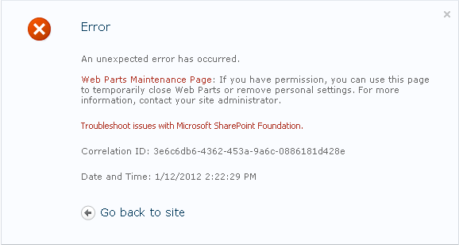
Figure 30 : EWISP – Permission error message
Please manually change web.config for the site that hosts the web part and add the following lines:
- In the node "configuration/system.web/httpModules"
<add name="Session" type="System.Web.SessionState.SessionStateModule" />
- In the node "configuration/system.webServer/modules"
<add name="Session" type="System.Web.SessionState.SessionStateModule, System.Web, Version=2.0.0.0, Culture=neutral, PublicKeyToken=b03f5f7f11d50a3a" />
- Change "enableSessionState" value in the node "configuration/system.web/pages" and set it to true

When I click on application icon, I get a HTTP 404 error.
Follow this article http://technet.microsoft.com/en-us/library/cc725608(WS.10).aspx to associate ‘.ica’ with ‘application/x-ica’ on the web server root site. This will be reflected on the SharePoint site as inherited. Also make sure the Citrix ICA client is installed on the client machine.

Uninstall script fails to uninstall the ewips.
If the uninstall.ps1 fails to uninstall the web part, we recommend the following:
- Open <sp_centraladministration_url>/_admin/Solutions.aspx and uninstall ExtentrixWebIntrface.wsp manually.
- Restart SharePoint Timer Service.

I get Type is not registered as safe.
I get this error message:
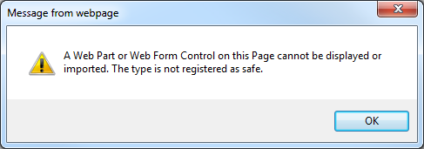
Figure 31 : EWISP – Type is not registered as safe error
Please check web.config of the site collection where deployed web part. In section "configuration/SharePoint/SafeControls" add the following line:
<SafeControl Assembly="ExtentrixWebIntrface, Version=2.8.0.0, Culture=neutral, PublicKeyToken=fb3e6e0ef08ace80" Namespace="ExtentrixWebIntrface.ExtentrixWIWebPart" TypeName="ExtentrixWIWebPart" SafeAgainstScript="True" />
For any support issues, please email your questions or problems to: support@extentrix.com

Glossary

Citrix XenApp: is a Windows® application delivery system that manages applications in the datacenter and delivers them as an on-demand service to users anywhere using any device.
Citrix Web Interface provides users with access to Citrix XenApp applications and content through a standard Web browser or through the Program Neighborhood Agent, and allows you to configure sites for MetaFrame Conferencing Manager Guest Attendee log on.
Microsoft SharePoint A content management system (CMS) with a suite of integrated capabilities, SharePoint helps improve organizational effectiveness. With comprehensive content management and enterprise search, SharePoint accelerates shared business processes, and facilitates information-sharing across boundaries – leading to better business insight.

Index

A
Administration Options, 25
Application Delivery, 7
C
Configuring the EWISP Web Part, 25
Content Redirection, 7
Customizing the EWISP Web Part, 21
F
Farms Administration Page, 25
File Locations, 8
G
Glossary, 31
H
How to use this guide, 6
I
Installation, 12
Installing EWISP, 10, 11
Introducing EWISP, 7
Introducing EWISP - Features, 7
Introduction, 6
L
Log Files, 30
M
Managing Farms, 25
Modifying the EWISP Web Part, 21
O
Other Features, 8
Other Requirements, 11
Other Requirements - Firewall, 11
Other Requirements - Hardware, 11
Other Requirements - Software, 11
P
Planning the Deployment, 10
Post Installation Tasks, 14
Pre-Requisites, 11
S
Sharepoint Deployments, 10
SQL Requirements, 11
Support, 30
T
Table of Contents, 3
Troubleshooting EWISP, 30
U
Uninstallation, 26

About Extentrix
Founded in 2006, Extentrix Systems is a leading software development company specializing in virtualization and developing custom software solutions for Citrix and Microsoft customers. Established by former software engineers at Citrix, Extentrix have developed access solutions that simplify and speed users’ access to Terminal Services and Citrix platforms.

